Experiment 2.1

**Aim:** *Formulate distance of an object using an ultrasonic sensor.*

# Objectives:

* *Learn about Ultrasonic Sensor.*
* *Learn about IoT programming.*

**Hardware:**

* *Arduino Uno R3 board*
* *Ultrasonic sensor (HC-SR04)*
* *16×2 LCD I2C Display*
* *Jumper Wires*

# Description:

***Arduino:***

*It is an open-source electronics platform. It consists ATmega328 8-bit Micro controller. It can be able to read inputs from different sensors & we can send instructions to the micro controller in the Arduino. It provides Arduino IDE to write code & connect the hardware devices like Arduino boards & sensors.*

***Ultrasonic Sensor***

*An ultrasonic Sensor is a device used to measure the distance between the sensor and an object without physical contact. This device works based on time-to-distance conversion.*

***Working Principle of Ultrasonic Sensor****:*

*Ultrasonic sensors measure distance by sending and receiving the ultrasonic wave. The ultrasonic sensor has a sender to emit the ultrasonic waves and a receiver to receive the ultrasonic waves. The transmitted ultrasonic wave travels through the air and is reflected by hitting the Object. Arduino calculates the time taken by the ultrasonic pulse wave to reach the receiver from the sender.*

*We know that the speed of sound in air is nearly 344 m/s,*

*So, the known parameters are time and speed (constant). Using these parameters, we can calculate the distance traveled by the sound wave.*

***Formula: Distance = Speed * Time***

*In the code, the “duration” variable stores the time taken by the sound wave traveling from the emitter to the receiver. That is double the time to reach the object, whereas the sensor returns the total time including sender to object and object to receiver. Then, the time taken to reach the object is half of the time taken to reach the receiver.*

*so we can write the expression as,*

***Distance = Speed of Sound in Air * (Time Taken / 2)***

*Note: Speed of sound in air = 344 m/s.*

# Code:

# *#define echoPin 8*

# *#define trigPin 9*

# *long duration;*

# *int distance;*

# *void setup()*

# *{*

# *pinMode(trigPin, OUTPUT);*

# *pinMode(echoPin, INPUT);*

# *Serial.begin(9600);*

# *Serial.println("Distance measurement using Arduino Uno.");*

# *delay(500);*

# *}*

# *void loop()*

# *{*

# *digitalWrite(trigPin, LOW);*

# *delayMicroseconds(2);*

# *digitalWrite(trigPin,HIGH);*

# *delayMicroseconds(10);*

# *digitalWrite(trigPin,LOW);*

# *duration = pulseIn(echoPin, HIGH);*

# *distance = duration * 0.0344 / 2;*

# *Serial.print("Distance: ");*

# *Serial.print(distance);*

# *Serial.println(" cm");*

# *delay(100);*

# *}*

# Output:

# 

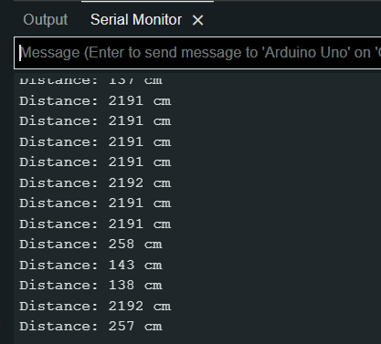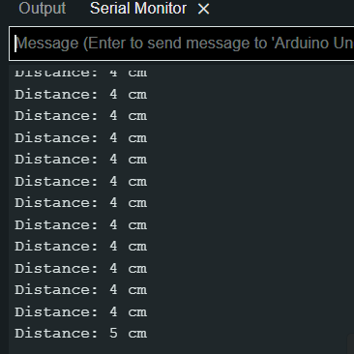

# Learning Outcomes:

1. *Learn the use of sensors.*
2. *Learn to perform task on real hardware without using any virtual platform.*
3. *Learn to know about how ultrasonic sensor works.*